Project Design Phase-II Technology Stack (Architecture & Stack)

|  |  |
| --- | --- |
| Date | **24.09.2022** |
| Team ID | **PNT2022TMID41917** |
| Project Name | Smart Solution for Railways |
| Maximum Marks | 4 Marks |

Technology Architecture:

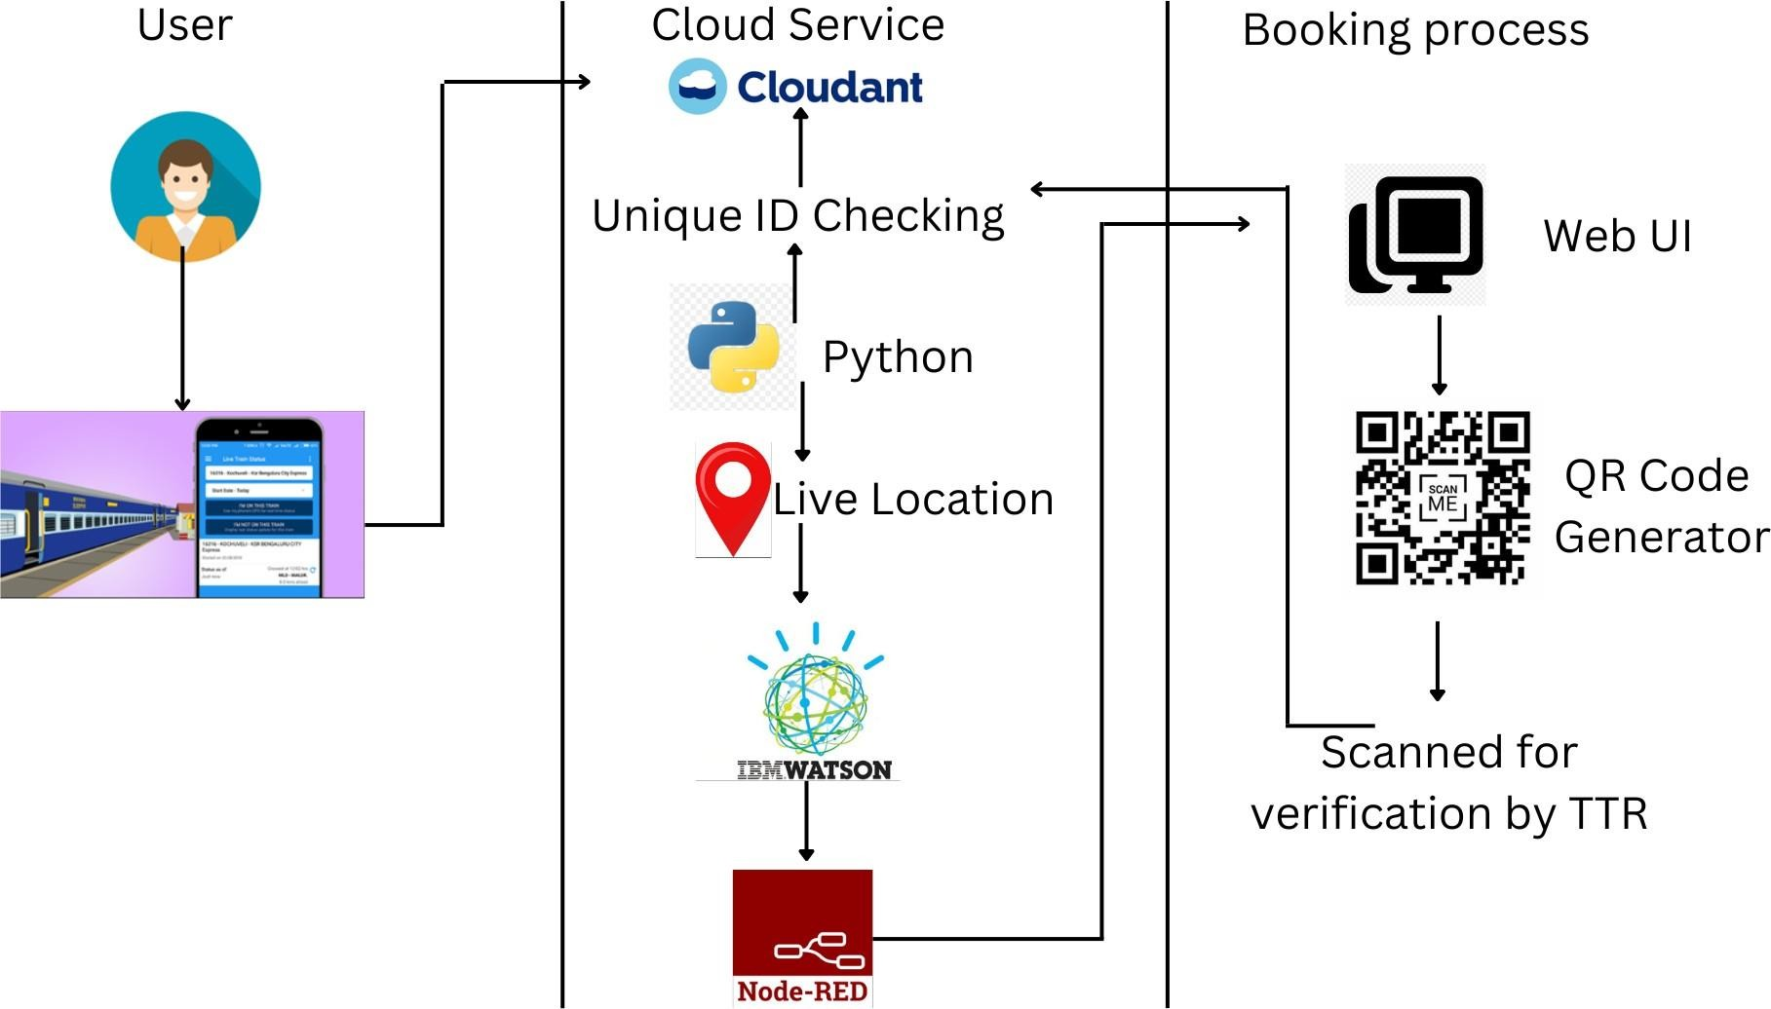

Table-1: Components & Technologies:

|  |  |  |  |
| --- | --- | --- | --- |
| **S.No** | **Component** | **Description** | **Technology** |
| 1. | Web UI | User can login and book their ticket through the website based on the availability of the seats. | HTML, CSS, JavaScript |
| 2. | Cloud Services | Requirements filled by the passenger is stored in the cloud database. | Python |
| 3. | GPS Tracking | Live Location details shared through the code to share the location in the website | IBM Watson Service |
| 4. | External API | Used for rail schedule, ticketing and travel documents generation, cancellation. | Sabre API |
| 6. | Data Processing | Ticket is verified with the unique ID generated with the cloudant DB | Python, IBM cloud |

Table-2: Application Characteristics:

|  |  |  |  |
| --- | --- | --- | --- |
| **S.No** | **Characteristics** | **Description** | **Technology** |
| 1. | Open-Source Frameworks | CSS, Backend framework, | Python, IBM cloudant DB |
| 2. | Security Implementations | Data entered are encrypted, Continuous Location Tracking | Python, Cloud service |
| 3. | Scalable Architecture | The scanner and the codes written are highly scalable where any implementation can be done anytime needed | Python |
| 4. | Availability | Any time available system. The ticket can be verified by the ticket collector from anywhere. | IBM Load Balancer |
| 5. | Performance | Though the details are get stored in the cloud the system crash will not affect the data. The data can be retrieved from anywhere with a scanner. And the GPS states the exact location of the train. | Distributed Services, GPS Tracker |